Case Analysis of Outsourcing by Tesco Plc

Executive Summary
The present study focuses on outsourcing strategic activities by an organisation to others. Such an approach of outsourcing is adopted when companies are unable to manage their existing business framework and simultaneously aim at enhancing efficiency levels even when expanding business horizon (Schniederjans, et al., 2015). The paper analyses the customer relationship management (CRM) of Tesco that has been outsourced by the company. This CRM is considered to be significant for Tesco as the company operates within the retail industry and CRM management is one of its most important processes. It is this CRM that ensures organisational relationship with its customers in the long run thereby ensuring that the company can generate maximised mutual benefits (Nding‘ori, 2015). Thus, considering the benefits of CRM, having an effective and efficient CRM process is a mandate for Tesco.
From the analysis, it has been derived that Tesco has outsourced its CRM to DunnHumby and Evans Hunt Scott (EHS). This decision has proved to be effective for the company along with being rewarding. Tesco has been able to gain and retain its leadership position with an effective outsourcing strategy. However, it is recommended that Tesco should also focus on the development of an in-house knowledge management system in the long run.

Table of Contents
Executive Summary 2
Introduction 5
Management of the Outsourcing activity by Tesco 6
Factors influencing the Outsourcing decision of Tesco 8
Evaluating implications of the Outsourcing decision 11
Conclusion and Recommendations 13
References 15

Introduction
It was in the year 1919, Tesco marked its first appearance in London by the establishment of a small market stall (Tesco Plc, 2021). From such humble beginnings, the company today has a marked presence in approximately, 13 different countries globally. The company also has an expanded product and service portfolio comprising of grocery products as well as other services like financial services (Tesco Plc, 2021). The increasing number of consumers Tesco has helped the company in securing a leadership position in terms of market share. Presently, Tesco provides 1.5 million deliveries through various slots depicting the scale of business and the number of consumers dealt by the company.
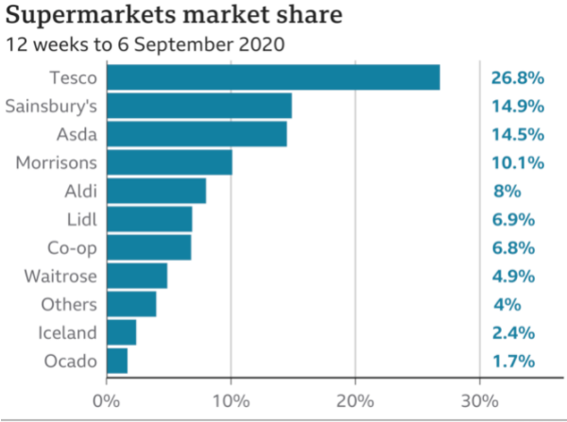
Figure 1 Market Share of Tesco
Source: (Simpson, 2020)
The management of such a big consumer base and endowing them with enhanced satisfaction demands for dedicated strategic approaches. For this, Tesco outsourced its CRM to ensure that it can focus on its core business activities.
For meeting the objectives of this paper, firstly the management of the outsourcing activity by Tesco has been analysed which is followed by determining the factor influencing the outsourcing decision by Tesco which has been analysed using Mclvor’s model. Finally, the study analyses the strategic and operational implications of the outsourcing decision by Tesco which is followed by a conclusion.

Management of the Outsourcing activity by Tesco
CRM ensures that Tesco can endow consumers with a higher level of satisfaction not only through the provision of products and services but also from the organisation itself. The importance of CRM is quite evident that are mainly retaining prevailing consumers and luring new consumers thus gaining market increased market share as well as competitive edge amidst intense competitive pressure. Along with these benefits, another reason for the outsourcing of CRM by Tesco was to avail cost advantages through cost reduction. By outsourcing CRM activities, it has been possible for Tesco to augment its efficiency levels by concentrating on its core retailing activities.
DunnHumby and Evans Hunt Scott are the two significant organisations to whom the CRM mechanisms of Tesco has been outsourced. For ensuring effective management of the CRM activities, Tesco ensures that DunnHumby is involved in the management of data as well as execute the analysis of the same. On the other hand, Evans Hunt Scott (EHS) is involved in the marketing of various strategies like the loyalty cards which has been developed and managed by EHS.
For management of organisational activities, as a part of the strategic decision making, CRM has been outsourced by Tesco. Though the company is one of the largest supermarkets in the UK, like every company, it too has resource limitations that can be used for the execution of core business activities and expansion. Also, for an organisation to be able to perform all the activities and excel in the same is challenging. Hence, for effective management, certain activities should be outsourced which has been done by Tesco too (Mudambi & Venzin, 2010). With the supermarket industry, competition is stringent and the pressure is intense. This is not only true within the national frontiers but also in the international markets. Considering that CRM is an essential element of retailing as done by supermarkets, it is difficult for companies to ignore the same. focusing on Tesco, management of CRM through in-house mechanisms was considered to be challenging as the company did not have the required competency for the same.
For the effective management of data and execution of efficient data analysis, the decision for outsourcing CRM to DunnHumby was taken. This decision proved to be quite a success in terms of benefits derived from the same as DunnHumby is deemed as a competent organisation in data management and analysis (Marr, 2018). the analysis of data by DunnHumby supported Tesco in determining the most appropriate consumer segments and develop CRM strategies targeted to them specifically thereby reaping exponential benefits. These CRM strategies were designed and executed in a manner that supported Tesco in retaining its customers thereby resorting to effective customer management. Also, customer services were augmented through features like customisation that further enhanced customer satisfaction levels making it effective for Tesco to manage its outsourcing decision (Patil, 2014). Effective demand management was also possible for Tesco by outsourcing its CRM. The data generated by DunnHumby appropriately helped Tesco in pursuing demand management. Strategic decisions like the addition of new products within the existing portfolio, deletion of non-moving products, or even overhauling the overall product/service portfolio was executed based on information analysed and provided by DunnHumby. Thus, product and service management were modernised and made effective by outsourcing CRM by Tesco which helped the company to meet consumer requirements with complete efficacy. The organisational financial efficiency of Tesco also multiplied as the investigation by DunnHumby provided the company with opportunities to augment its cash revenues by optimum utilisation of the reserved assets too (McDonald, 2015).
When the outsourcing decision was taken, Tesco was subjected to a series of challenges that demanded effective management. Some of these challenges faced were the commitment of resources which required huge investments, incompetent employees as no one had knowledge about management and dealing of loyalty cards, availability of elementary technology and need for adequate plastics to print the cards. Initially, the company proposed to print 20 million cards for which it lacked appropriate infrastructure and business processes (Hutchinson, 2019). These challenges were mutually dealt with by Tesco and DunnHumby. Though Tesco has outsourced its CRM activities to DunnHumby the relationship between them is managed as partners (Hutchinson, 2019). With the help of advanced technologies like data analytics, DunnHumby ensures that the CRM of Tesco is effectively managed.
The data management of the loyalty cards was done by DunnHumby but it was EHS that was involved in the development of these loyalty cards. EHS based on market study and detailed analysis of the requirements of Tesco designed these loyalty cards which helped the company collect the required data which when analysed provided for effective outcomes. EHS developed club cards that assisted Tesco in gaining an insight into the consumers and use this information as a strategic asset for desired strategic planning (Campaign Live, 2005).
The management of the relationship with the outsourced companies by Tesco though needs been managed as a buyer-seller relationship but was managed in form of a partnership. The companies involved in this outsourcing contract was driven by conviction between them as well as acknowledgement of responsibilities of the members involved (Martins, et al., 2018). The analysis highlights that management of outsourcing has been challenging for Tesco but yet effective. Tesco has derived significant benefits irrespective of the challenges faced.

Factors influencing the Outsourcing decision of Tesco
The various factors influencing the outsourcing decision of Tesco can be analysed using Mclvor’s model. The model has been shown in the figure below:
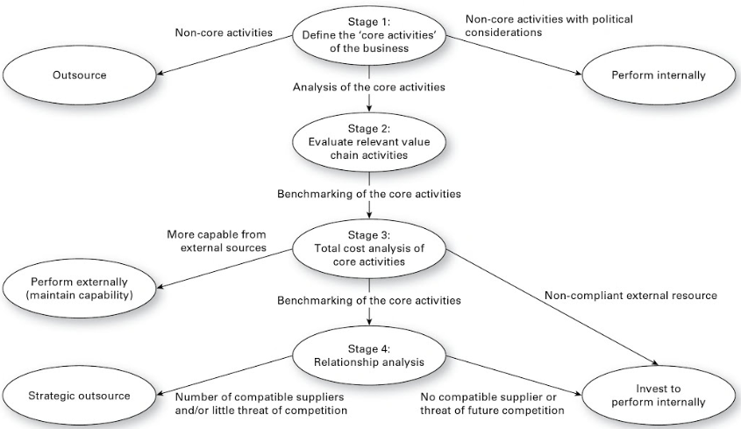
Figure 2 Mclvor’s Outsourcing Model
Source: (Richards, 2014)
As evident from the above model, there are specifically two significant reasons that are responsible for motivating an organisation to outsource its activities to others. Thus, organisations as inferred from the above diagram outsource owing to tactical and strategic reasons which for Tesco has been discussed in this section.
One of the most significant factors influencing outsourcing decision for Tesco has been the achievement of cost efficiencies through cost minimisation. The overall business model and strategy of Tesco has been driven by the principles of cost leadership (Cuthbertson, et al., 2015). Under this approach, the company aims at endowing its consumers with products and services at much lower prices without compromising on quality parameters. To generate profits the company seeks to minimise costs thereby enhancing revenues even through limited profit margins. However, by executing CRM itself Tesco couldn't achieve this objective.
CRM management even with the help of various software and advanced technologies is challenging. It is mainly because it demands time and resource dedication which is intricate for companies like Tesco to manage who already have a widely diversified business portfolio. For CRM management effective and advanced technologies are required along with required expertise which Tesco was deficient in (Marr, 2009; Xie & Allen, 2013). For resorting to CRM activities, there was a need for adopting advanced technologies by Tesco which demanded additional investment requirements. Also, there is a continuous need for maintaining and upgrading the technologies to meet the dynamic business and consumer requirements. These actions demand increased costs thus influencing the cost structure of the company. Another important component needed for the effective pursuit of CRM activities there is a need for higher expertise which depicts increased human resources costs. Considering incurring of costs in so many different areas related to CRM, outsourcing is deemed to be more effective and an optimistic decision by the company (Mudambi & Venzin, 2010).
By outsourcing the CRM activities, the company has been able to minimise thereby optimising its costs which meets its tactical parameters of outsourcing. On the other hand, this cost leadership and higher efficiency endow the company with a competitive edge within the supermarket industry thus helping the company retain its leadership position (Tesco Plc, 2021).
Quality enhancement has been another significant factor that has influenced Tesco to take the outsourcing decision. With the strategic decision of outsourcing, it has been possible for the company to achieve its mission and vision effectively by concentrating on the integral activities. Quality improvement is one of them.

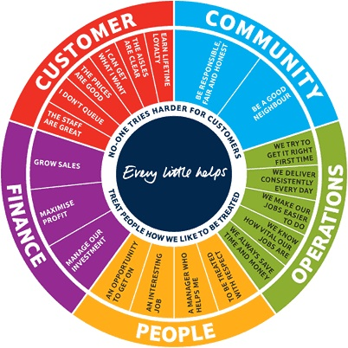
Figure 3 Tesco’s Steering Wheel showing its Vision and Mission
Source: (Tesco Plc, 2021)
The quality focus of Tesco has been rewarded by the fact that in the year 2015, its quality score was 13+ whereas in the year the same score was 18+ (Brand Index, 2016). This is owing to the augmented customer satisfaction that has resulted in the development of positive perception in them.
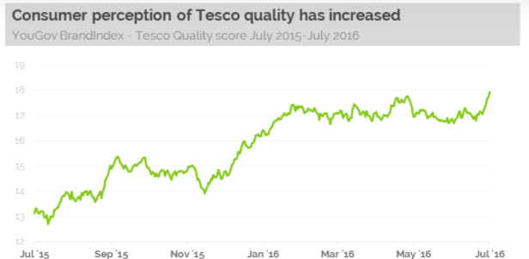
Figure 4 Quality Score of Tesco
Source: (Brand Index, 2016)
Quality has been of paramount importance for Tesco and with outsourcing, it has been possible. It is mainly because Tesco has been able to provide augmented customer services. Outsourcing of CRM helped Tesco to target the right consumers and manage relationships with them in an effective manner (Al-Suraihi, et al., 2020). This has in turn helped the company to retain existing consumers and attract new ones. With outsourcing, Tesco has been in a position to provide augmented services to its customers which helps the company to gain a competitive edge within the industry.

Evaluating implications of the Outsourcing decision
The outsourcing decision by Tesco has had significant strategic implications at both strategic and operational levels on the functioning of the company. At a strategic level, Tesco has been in a position to develop strong brand loyalty within its consumers with the help of Clubcard. This has in turn endowed the company with strong competitive advantages within the retail industry.
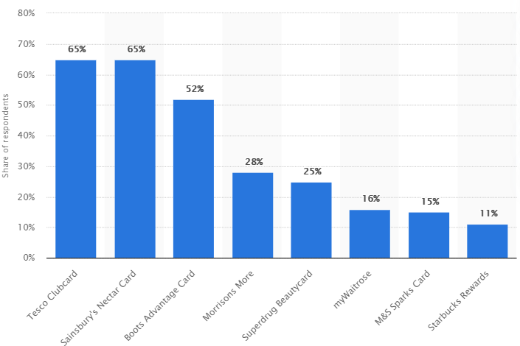
Figure 5 Loyalty card uptake in the United Kingdom (UK) 2016
Source: (Sabanoglu, 2018)
Initially, with the introduction of the club cards, the company faced challenges in the management of the same owing to demands for effective big data management. But with the help of partner companies who have been responsible for its management, Tesco has experienced augmented sales which have resulted in increased revenue for the company. Tesco's competitive position also got nurtured. In terms of market share within the grocery industry, Tesco has been a market leader as shown in the figure below:
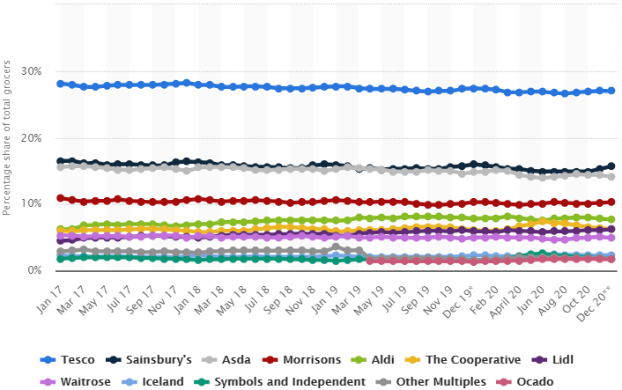
Figure 6 Grocery market share in Great Britain 2017-2020
Source: (Coppola, 2021)
With the help of the information availed through the club cards by Tesco, the company develops customised services for its customers. One such service is the quarterly magazine. For this, Tesco has identified specific customer segments based on the data analysed related to consumer shopping. For each of these specific segments, Tesco developed quarterly magazines containing information of interest specific to the segment (Peppers & Rogers, 2016). Along with the articles of interest, promotions and discount offers were also related to customer’s interest area. These promotions and discount coupons were thus for those product and service category that the specific customer is more probable to buy. The outcome was positive and the company was able to create a strong base of loyal consumers.
This customisation assisted Tesco to attract advertisements for its quarterly magazines which thereby turned out to be an additional source of income for the company. Hence, the CRM strategy added to organisational revenues not only through increased customer loyalty but through additional sources of income (Mollah, 2014). Another implication of these club cards was that the customer data collected from this helped Tesco to expand its business horizon and enter the financial services industry too. The data collected through the club cards assisted Tesco to reach the consumers who are most probable to choose the financial services offered by the company. According to this data analysis, Tesco targeted the consumers and benefitted through cross-selling (Mollah, 2014). As Tesco already had complete information about the segment consumers and their behaviour it was easy for the company to target them. The cost of acquisition involved was also lower for Tesco's financial services which supported its strategic approach for cost-minimisation.
Another significant implication of a planned decision of CRM outsourcing by Tesco was its expansion within the online forum by setting up its e-commerce portal. Tesco entered the online supermarket retailing much ahead of its competitors and it was possible only primarily because, the company had complete knowledge about its target consumers and thus could analyse their readiness to shop online (Chapman, 2013).
It was only through outsourcing that Tesco was able to plan its expansion in different business sectors which is its core business. This eventually helped the company to generate strategic and operational implications in a positive manner.

Conclusion and Recommendations
Overall, it can be concluded, that the decision for outsourcing by Tesco has been efficient as the company continues to retain its leadership position within the industry across the globe.
The outsourcing decision by Tesco has been quite successful and effective which is evident from the increasing consumer loyalty and market share of the company. Outsourcing decision has helped the company to meet its business mission along with reaping benefits through outsourcing (Iqbal & Dad, 2013). The global success achieved by Tesco has been to a larger extent driven by the successful CRM strategy of the company which has been outsourced by the same. The supermarket industry in which Tesco operates has been subjected to stringent competitive pressure. This pressure is exercised by the direct competitors as well as those from the substitutes within the national and international markets. As Tesco, continues to expand its business horizon it is significantly critical for the company to develop a business model that is robust and competent to support the achievement of organisational vision and mission. With the strategic decision of outsourcing, it has been possible for Tesco to a larger extent to expand while dealing with these market dynamics and at the same time achieve its business goals.
Irrespective of significant success made through outsourcing there are certain areas that Tesco might need to focus upon to continue to derive benefits from such a strategic decision. It is recommended that Tesco should have operative and efficient knowledge management systems (KMS) (Centobelli, et al., 2019). This KMS needs to be managed by Tesco itself as an individual department. This will help the company to overcome hindrances that are caused owing to data threats wherein confidentiality of the data is under fears. With an in-house KMS system that would be integrated with the outsourced companies, Tesco would also be in a position to derive benefits from augmented supply chain efficacies (Centobelli, et al., 2019).
Secondly, it is recommended that Tesco should enhance its communication systems that is prevalent amid itself and the companies to which it has outsourced its activities. This will assist Tesco in enhancing its overall efficiency levels through increased efficacy of the outsourced organisations (Bals & Tate, 2017). Thirdly, along with enhanced communication, Tesco should overhaul and redesign its quality control standards for its outsourced companies. Through defined quality control mechanisms, it is possible for Tesco to ensure that CRM standards are met and there are no inconsistencies in services delivered to the consumers.

References
Al-Suraihi, W. et al., 2020. The Effect of Customer Relationship Management on Consumer Behavior: A Case of Retail Industry in Malaysia. International Journal of Management and Human Science, 4(3), pp. 32-40.
Brand Index, 2016. Five ways Tesco has strengthened its position. [Online]
Available at: https://yougov.co.uk/topics/consumer/articles-reports/2016/07/21/five-ways-tesco-has-strengthened-its-position
[Accessed 15 Apr 2021].
Campaign Live, 2005. The Power 100. [Online]
Available at: https://www.campaignlive.com/article/power-100/472337
[Accessed 14 Apr 2021].
Centobelli, P., Cerchione, R. & Esposito, E., 2019. Efficiency and effectiveness of knowledge management systems in SMEs. Production Planning & Control, 30(9), pp. 779-791.
Chapman, A., 2013. Clubcard is 'key' to Tesco's online shopping evolution. [Online]
Available at: https://www.campaignlive.co.uk/article/clubcard-key-tescos-online-shopping-evolution/1217478
[Accessed 16 Apr 2021].
Coppola, D., 2021. Grocery market share in Great Britain 2017-2020. [Online]
Available at: https://www.statista.com/statistics/280208/grocery-market-share-in-the-united-kingdom-uk/
[Accessed 15 Apr 2021].
Cuthbertson, R., Furseth, P. & Ezell, S., 2015. Tesco and Sainsbury’s: The Need to Turn Ideas into Action. In: Innovating in a Service-Driven Economy. London: Palgrave Macmillan, pp. 159-165.
Hutchinson, P., 2019. Dunnhumby and Tesco Partnership. [Online]
Available at: http://www.fmcgcentral.co.uk/resources/blog/2019/03/dunnhumby-and-tesco-partnership/
[Accessed 14 Apr 2021].
Iqbal, Z. & Dad, A., 2013. Outsourcing: A review of trends, winners & losers and future directions. International Journal of Business and Social Science, 4(8).
Marr, B., 2009. Delivering Success: How Tesco is Managing, Measuring and Maximising its Performance, Milton Keynes: The Advanced Performance Institute.
Marr, B., 2018. Tesco: Measuring Customer Performance & Gaining Insights From The Clubcard Data. [Online]
Available at: https://www.bernardmarr.com/default.asp?contentID=1057
[Accessed 13 Apr 2021].
Martins, A., Duarte, H. & Costa, D., 2018. Buyer–supplier relationships in IT outsourcing: consultants’ perspective.. The International Journal of Logistics Management, 29(4), pp. 1215-1236.
McDonald, C., 2015. Tesco decides to keep Dunnhumby after strategic review of business. [Online]
Available at: https://www.computerweekly.com/news/4500254993/Tesco-decides-to-keep-Dunnhumby-after-strategic-review-of-business
[Accessed 13 Apr 2021].
Mollah, A., 2014. The impact of relationship marketing on customer loyalty at Tesco Plc, UK.. European Journal of Business and Management, 6(3), pp. 21-55.
Mudambi, R. & Venzin, M., 2010. The strategic nexus of offshoring and outsourcing decisions. Journal of Management Studies, 47(8), pp. 1510-1533..
Nding‘ori, H., 2015. Factors Affecting Outsourcing of Customer Service of Airtel Networks Kenya Limited. IOSR Journal of Business and Management, 17(7), pp. 125-154.
Patil, R., 2014. SUPERMARKET GIANT TESCO PIONEERS BIG DATA: TURNING CUSTOMER LOYALTY INTO ROYALTIES. [Online]
Available at: https://dataconomy.com/2014/02/tesco-pioneers-big-data/
[Accessed 13 Apr 2021].
Peppers, D. & Rogers, M., 2016. Managing Customer Experience and Relationships: A Strategic Framework. 3 ed. New Jersey: John WIley and Sons.
Richards, G., 2014. Warehouse Management: A Complete Guide to Improving Efficiency and Minimizing Costs in the Modern Warehouse. 2 ed. London: Kogan Page Publishers.
Sabanoglu, T., 2018. Loyalty card uptake in the United Kingdom (UK) 2016. [Online]
Available at: https://www.statista.com/statistics/684551/loyalty-card-uptake-united-kingdom-uk/
[Accessed 15 Apr 2021].
Schniederjans, M., Schniederjans, A. & Schniederjans, D., 2015. Outsourcing and insourcing in an international context. Oxon: Routledge.
Simpson, A., 2020. Tesco profits surge as online orders double. [Online]
Available at: https://www.bbc.com/news/business-54445399
[Accessed 14 Apr 2021].
Tesco Plc, 2021. About Us: History. [Online]
Available at: https://www.tescoplc.com/about-us/history/
[Accessed 12 Apr 2021].
Tesco Plc, 2021. About us: Tesco plc.. [Online]
Available at: http://www.tescoplc.com/plc/about_us/
[Accessed 15 Apr 2021].
Xie, Y. & Allen, C., 2013. Information technologies in retail supply chains: a comparison of Tesco and Asda. International Journal of Business Performance and Supply Chain Modelling, 5(1), pp. 46-62.

